**Project Stress Compass**

**Dataset Source and Description**

This project utilizes a dataset titled "StressLevelDataset.csv". The data was obtained from a public domain source, specifically designed for data analysis the mental health status of students between the education from intermediate to college students from their academics and environment. It is a comprehensive snapshot of various metrics related to student well-being.

The original dataset contained **1,100 rows** and **21 columns**. To focus the analysis and create a more streamlined dashboard, the data was pre-processed in Power BI. This involved:

* Reducing the total number of rows to **300** to represent a targeted sample size.
* Removing several columns that were not central to the project's core objectives, such as headache, noise_level, social_support, bullying, teacher_student_relationship, and basic_needs.

The resulting, refined dataset includes key numerical fields such as anxiety_level, depression, sleep_quality, and academic_performance, which are essential for understanding the psychological, physical, and academic factors influencing a student's stress_level.

**Business Problem**

There is a AI startup, named Saivy tech they are currently working on to built a optimized best of best AI tool to deal with today’s generation stress level specially from age 18 to 25 ,so in order to get some insights from data on which they will train their AI Model, I have Asked by their Business Executive to show some dashboard to give some meaning full results.

This report outlines key insights from an analysis of student stress data. The findings are intended to inform and optimize the development of an AI tool designed to help young adults manage and reduce their stress levels. By understanding the primary drivers of stress—including mental well-being, academic pressures, and environmental factors—the AI tool can be tailored to provide personalized, effective support.

AI Tool Focus Area demanded by Company

AI-Tool Focus Area: The Core Mental Health-Stress Connection.

AI-Tool Focus Area: The Core Mental Health-Stress Connection.

AI-Tool Focus Area: Lifestyle and Environmental Intervention.

. AI-Tool Focus Area: Actionable Insights for Users.

**Key Insights From Dashboard**

*The Core Link Between Mental Health and Stress*

The Scatter Chart is highly effective at showing the relationship between anxiety level, depression, and stress level. The visual confirms a strong positive correlation between anxiety and depression. Students with higher anxiety levels also tend to have higher depression scores. Most importantly, the color coding shows that students with a high average stress level (the green points) are generally found in the top-right area of the chart, where both anxiety and depression scores are high. This is a crucial finding that suggests mental well-being is a primary driver of overall stress.

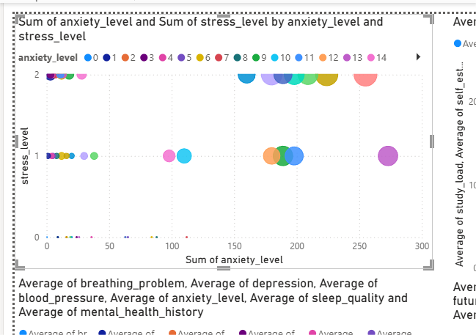

*The Impact of Academic & Environmental Factors*

The **Bar Charts** provide clear insights into how academic and living conditions affect stress.

**Bar Chart** compares stress level to academic performance. It's clear that students with a low academic performance have a much higher average stress level compared to those with a better performance. This directly links poor grades to increased stress.

**Next Visual** shows the relationship between stress level and living conditions. The chart indicates that students with poor living conditions (likely represented by the lower scores) experience a significantly higher average stress level. This highlights that a student's environment is a key factor in their well-being.

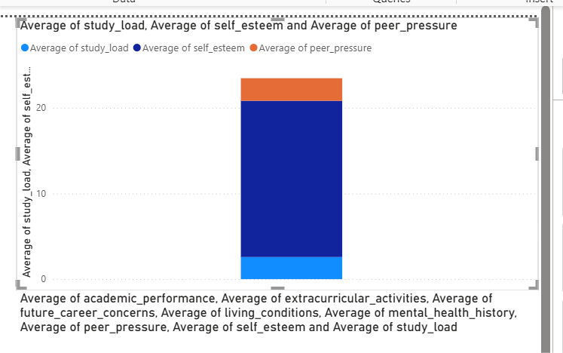

*The Role of Physical and Social Factors*

The **Pie Chart** focuses on the physical and social aspects of stress.

The comparison between breathing problem and stress level suggests that students who report more breathing problems also have a higher average stress level.

Similarly, the chart comparing sleep quality and stress level likely shows that poor sleep quality is directly linked to higher stress.

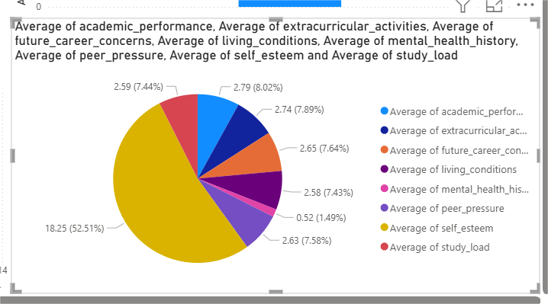

**Summary of Key Insights**

The dashboard successfully identifies the primary drivers of student stress by using visuals that each tell a focused story. The main takeaways are:

* **Mental well-being is a top priority:** High levels of anxiety and depression are strongly correlated with high stress.
* **Academic and environmental factors are significant:** Poor academic performance and unfavorable living conditions are key contributors to increased stress.
* **Physical health matters:** Issues like poor sleep quality and breathing problems are associated with higher stress levels.